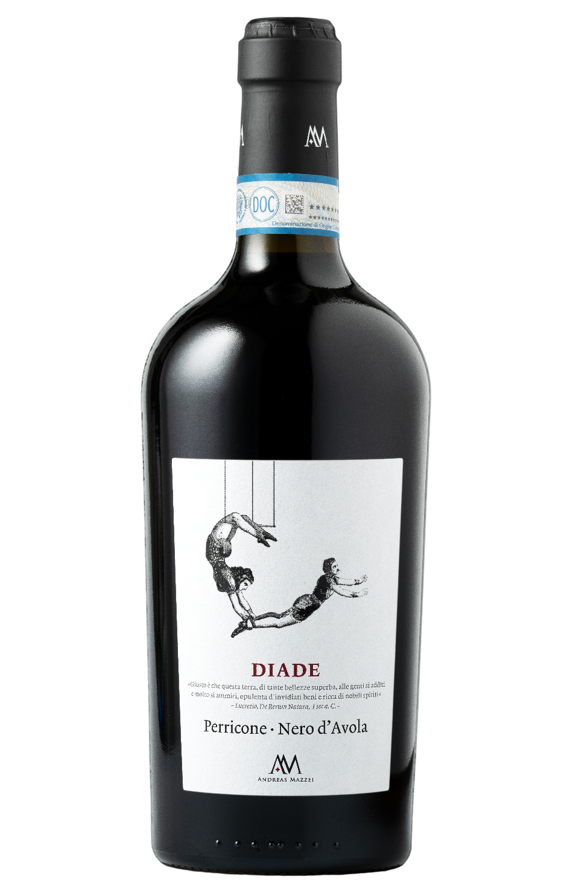
PERRICONE NERO D’AVOLA DOP – DIADE
Wine made with the two autochthonous Sicilian grapes Perricone (80%) and Nero d’Avola (20%). After being overlooked for a long time, owing
mostly to its low productivity levels, Perricone is now being seen in a new light. This is mainly thanks to its complex and elegant characteristics. The
marriage with Nero d’Avola adds further richness in terms of fruitiness, softness and body. Thanks to this blending we obtain a dyad (DIADE), a unique wine made of two very different composing elements.

Grape: Perricone 80% Nero d'Avola 20%
Alc. Vol.%: 14,5
Vintage: 2023
Residual sugar g/l: 6,0
Total acidity g/l: 5,8
Region: Sicily
Production zone: Vineyards in Western Sicily
Capacity: 750ml

CHARACTERISTICS

Vinification: Fermentation in steel tanks at a controlled temperature
Aging: 12-18 months in oak and steel
Yield per ha: 9000kg
Colour: Intense and purple red
Bouquet: Fruity yet spicy scents
Flavour: Full-bodied, complete, absorbing taste, with elegant tannins in the finale

SERVING SUGGESTIONS

Best enjoyed with hearty dishes, with strong flavours, or even spicy dishes, like grilled meat, roasted meat, game and mature cheeses.
Serving temperature 18 °C
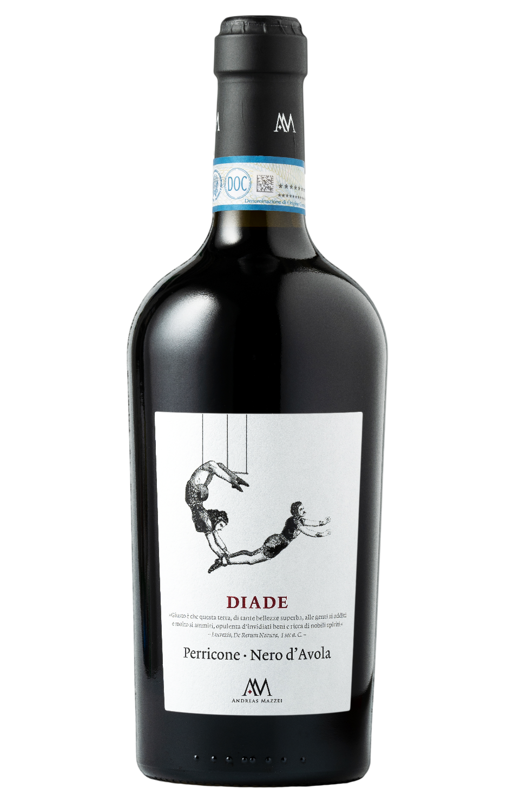
TECHNICAL INFORMATION / PALLETIZING

Size 750ml:
Article Nr. V04003A
GTIN-13 bottle 8017868003557
GTIN-13 carton 8017868003601
Closure Cork
Bottles / carton 6 bottles
Pallet size 80x120cm
Cartons/layer 17
Cartons/pallet 102
Kg/carton 10
Kg/pallet 820

Contains sulphites
GMO Free
Revisione 02. 01.10.2026

